**Now in order to create index**, First we need to find unique columns in our collection

There are total of 8 columns mainly "_id","Area Type","Area Name","Year","Month","Date","Series Code","Industry Title","Seasonally Adjusted","Current Employment"

We will run following queries :-

db.Project.distinct('Area Type').length

db.Project.distinct('Area Name').length

db.Project.distinct('Year').length

db.Project.distinct('Month').length

db.Project.distinct('Date').length

db.Project.distinct('Series Code').length

db.Project.distinct('Industry Title').length

db.Project.distinct('Seasonally Adjusted').length

db.Project.distinct('Current Employment').length

db.Project.distinct('_id').length

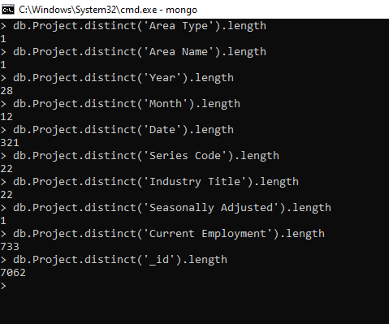

As it is clear from above screenshot, only “_id” column is unique in collection

“Area Type”, “Area Name” and “Seasonally Adjusted” are same for all 7062 collections

We need to build our indexes based on following columns:-

Year ,Month, Date , Series code ,Industry Title and Current Employment

We can either